

Course Name
Computer Programming Lab
Lab Title
Working in Python environment: Arithmetic Operations- Variables, and Data Type

Name | Registration Number | Lab #
Muhammad Hamzah Iqbal | F24604018 | 1
Date | Instructor’s Name | Instructor’s Signature
27/2/2024 | LE Ayesha Ashfaque

Objective:

- To have basic understanding of if-else Statements in Python.
- To understand Nested if statements and else-if statements.

Theoretical Aspect

This lab introduces fundamental Python concepts, including arithmetic operations, variables, and data types. It emphasizes operator precedence, variable assignments, and string manipulation.

Experimental Procedure

Task 01:
Your university registration number shows the year of your intake. For example, in the
enrolment 201918 the first two numbers show your intake i.e. 20. Write a python program which takes enrolment as an input and finds in which year you are enrolled.

Algorithm:

- Start
- Prompt the user to enter their roll number
- Store the input as an integer variable
- Extract the enrollment year using integer division (// 10000)
- Print the enrollment year in the format "20XX"
- End

Flow Chart:

Start

Enter the roll no:

Store Roll number in roll

Calculate floor value using
year = roll //10000

Display year

End

Task 02: Write a python program to find the largest number among the three user input numbers.

Algorithm:
- Start
- Prompt the user to enter the first number and store it
- Prompt the user to enter the second number and store it
- Prompt the user to enter the third number and store it
- Check if the first number is the greatest
- If true, print it as the greatest
- Otherwise, check if the second number is the greatest
- If true, print it as the greatest
- Otherwise, print the third number as the greatest
- End

Flowchart
Start

Input a string

Store string in variable String.
Use len function to find length of string and then store it in length

Display the length of the string

End

Task 03: Write a python code to check wheatear a number is prime or not.

Algorithm

- Start
- Prompt the user to enter a number and store it
- Check if the number is greater than 1
- If true, proceed to the next step
- Otherwise, print "The number is not prime" and end
- Loop from 2 to one less than the number
- Check if the number is divisible by any value in this range
- If divisible, print "The number is not prime" and exit the loop
- If no divisor is found, print "The number is prime"
- End

Flowchart

Start

Ask user to input 2 strings separately

Add the 2 strings

Display the joined string result
End

Task 04:
Write a python code to check wheatear a number is even or not.

Algorithm

- Start
- Prompt the user to enter a number and store it
- Check if the number is divisible by 2
- If true, print "Number is even"
- Otherwise, print "Number is odd"
- End

Flowchart

Experimental Results

Task 1:

Code:

r=float(input("Enter the radius : "))
pi=3.14
area=pi*(r**2)
print("Area of the circle with radius ",r," is equal to : ",area)

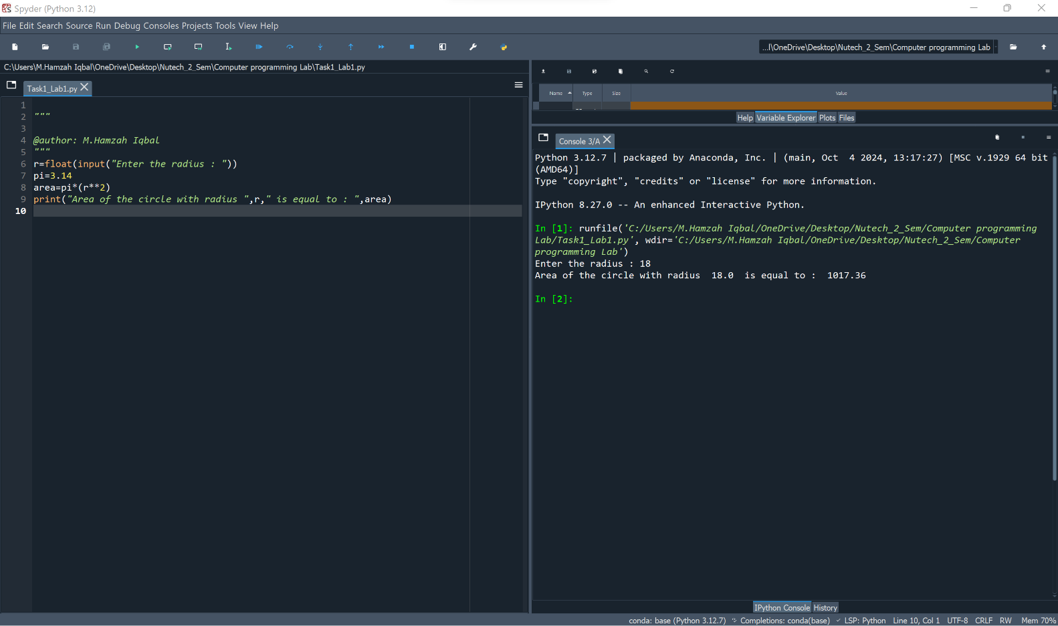

Figure 1 Finding Area

Task 2:

Code:

String=input("Enter a sentence : " )
length=len(String)
print("The length of the sentence you have entered is : ",length)

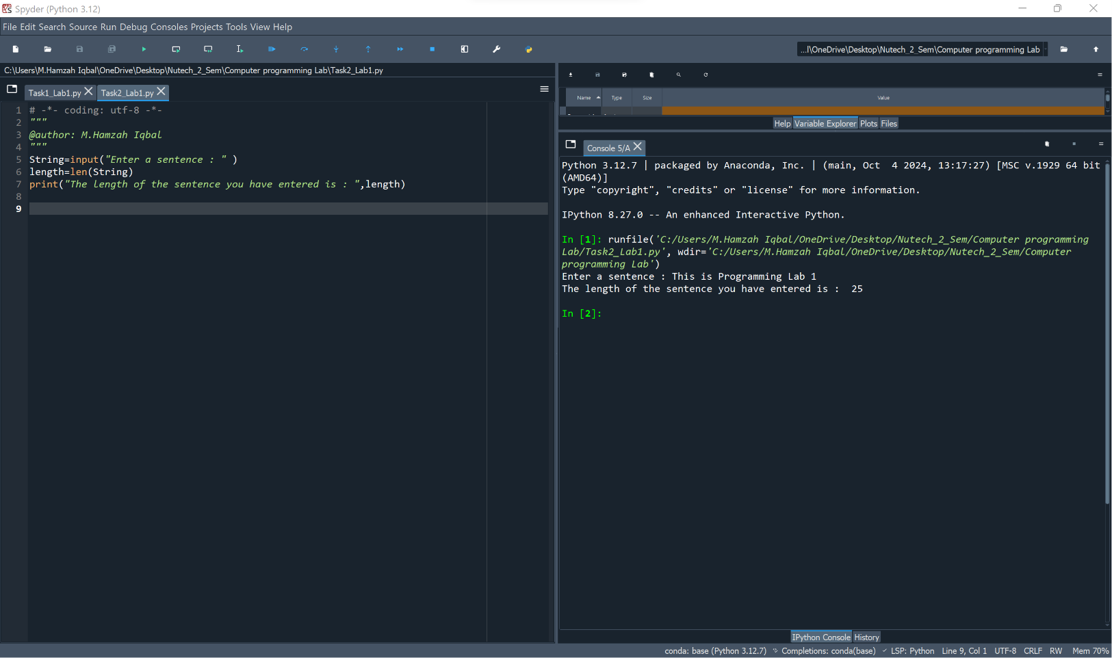

Figure 2 Finding Length of String

Task 3

Code
String_1=input("Enter a sentence : ")
String_2=input("Enter another sentence : ")
Together=String_1+String_2
print("Your Sentences combined together : ",Together)

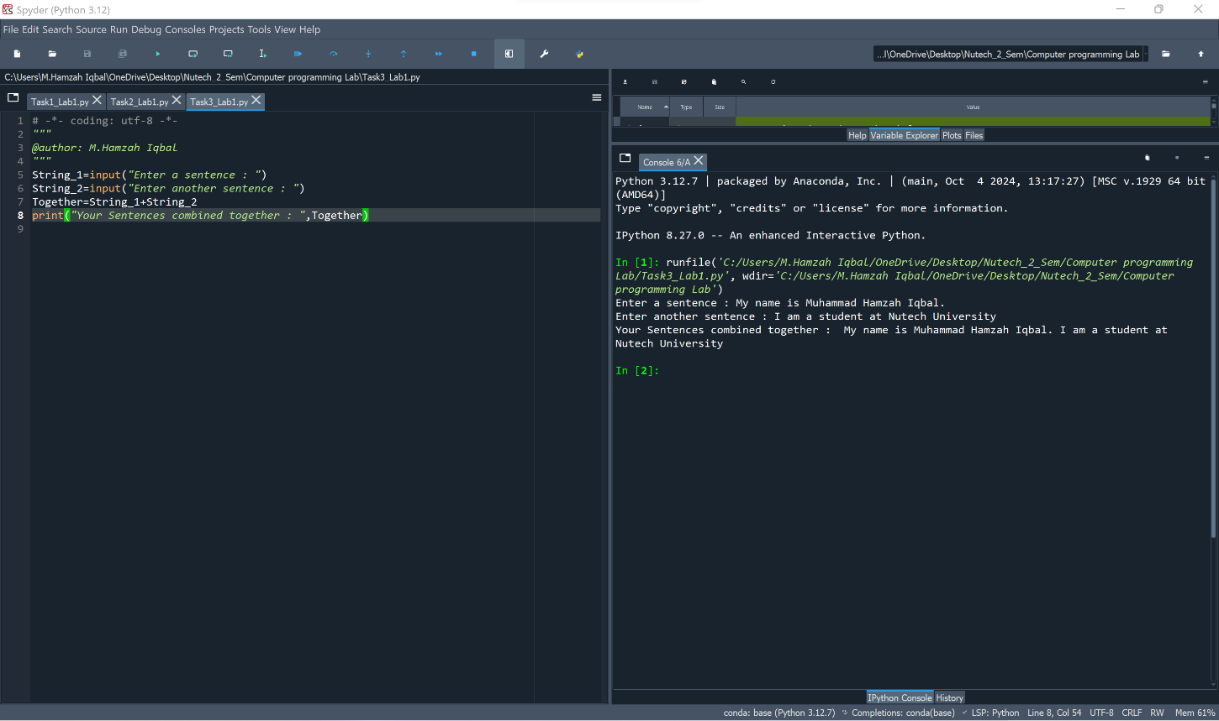

Figure 3 Combining Two Strings

Discussion of Results

In this lab, we performed three tasks using Python to explore basic programming concepts.

Task 1 (Area of a Circle): We used a predefined value of pi and a given radius to calculate the area using the formula Area = pi × (radius²). The result was displayed correctly, demonstrating how mathematical operations and variable assignments work in Python.

Task 2 (String Length): We took a user-input string and found its length using Python’s built-in len() function. This showed how we can efficiently determine the size of a string, which is useful in text processing applications.

Task 3 (String Concatenation): We took two strings from the user and joined them using the + operator, illustrating how Python handles string manipulation. This concept is widely used in formatting and text-based applications.

Conclusions

This lab introduced fundamental programming skills, including mathematical calculations, string handling, and user input processing in Python. By applying these techniques, we gained practical experience in handling variables, functions, and operations that are essential for programming and real-world applications like data processing and automation.

